VIDEO GAME SALES AND RATING
Fathima Sabeeha T
Batch 69

Data set:
https://www.kaggle.com/datasets/thedevastator/video-game-sales-and-ratings

Introduction
The video game industry is one of the largest entertainment sectors in the world. Games are released on many platforms, in many genres, and sold across different regions every year. With so many titles competing for players, publishers need evidence of what sells and why, rather than relying on guesswork. It contains game details such as name, platform, year of release, genre, publisher, developer and age rating. It also has sales figures for North America, Europe, Japan, other regions and globally, plus critic scores, user scores and review counts.

Business Goal
The business goal is to help a game publisher or studio decide which kinds of games to develop, publish and market, and where to release them, by finding what drives sales performance.

Cleaning in excel

- there is two row has no name no genere its deleted.
HOME-remove row

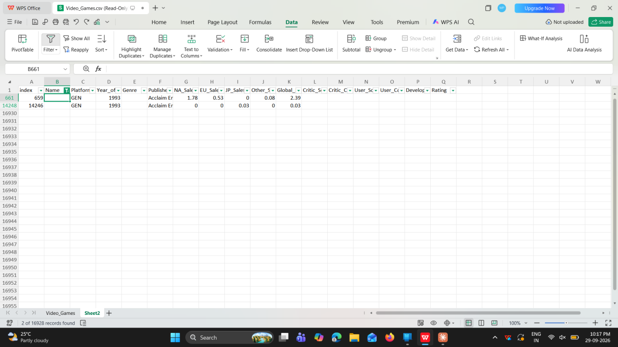

- there is lot missing value
Missing values: Year_of_Release (273), Publisher (55), Critic_Score Critic_Count (8,668), User_Count (9,210), Developer (6,688), Rating (6,836).
Year of relese leaves blank,publisher,devoloper replaced with “unknown”.
For publisher coloum
=IF(ISBLANK(G2),"Unknown",G2)
For devolper coloum
=IF(ISBLANK(V2),"Unknown",V2)
lRating replaced with not rated
=IF(ISBLANK(X2),"Not Rated",X2)
Critic score ,critic count,user score,user count replaced with median
=IF(ISBLANK(N2),MEDIAN(N2:N16927),N2)

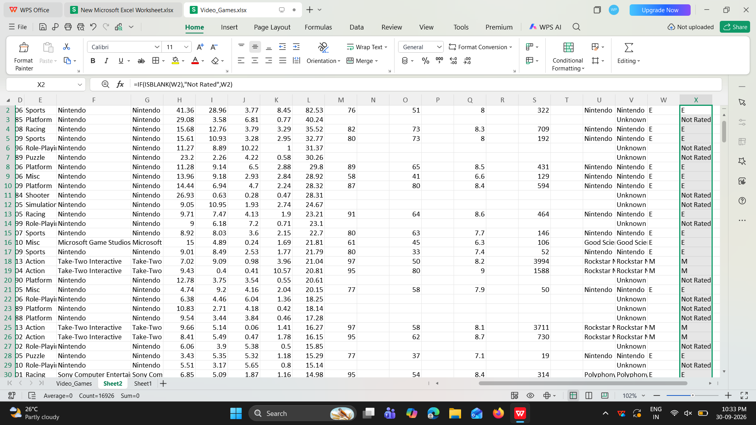

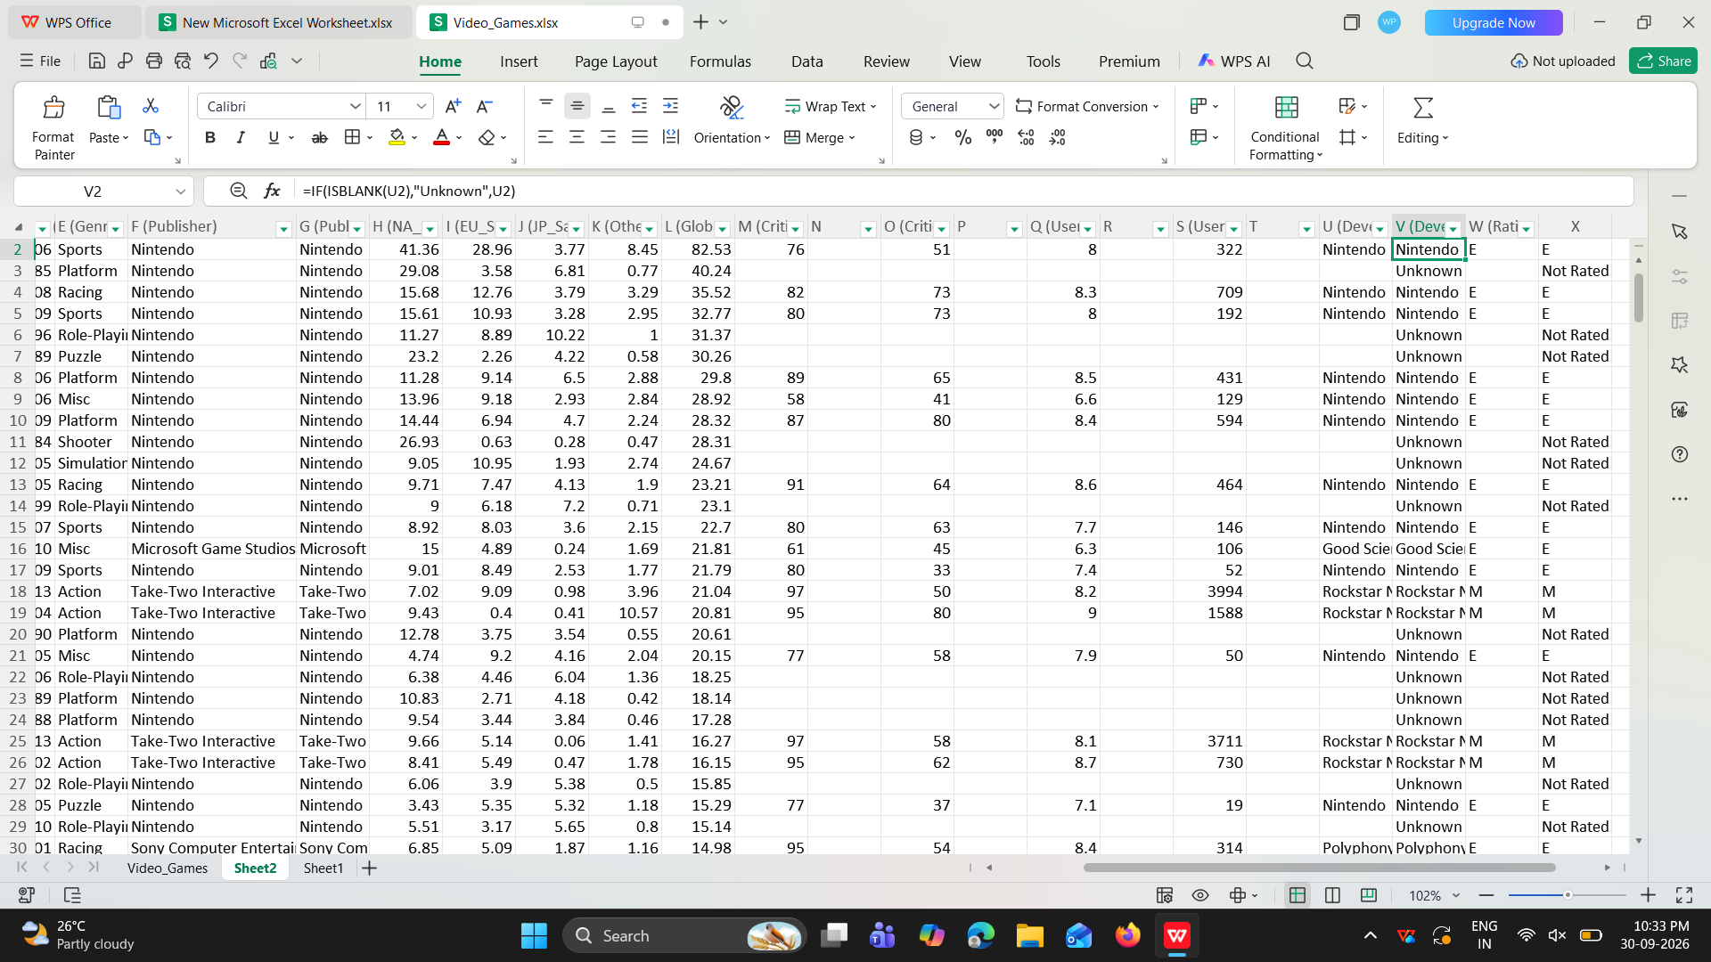

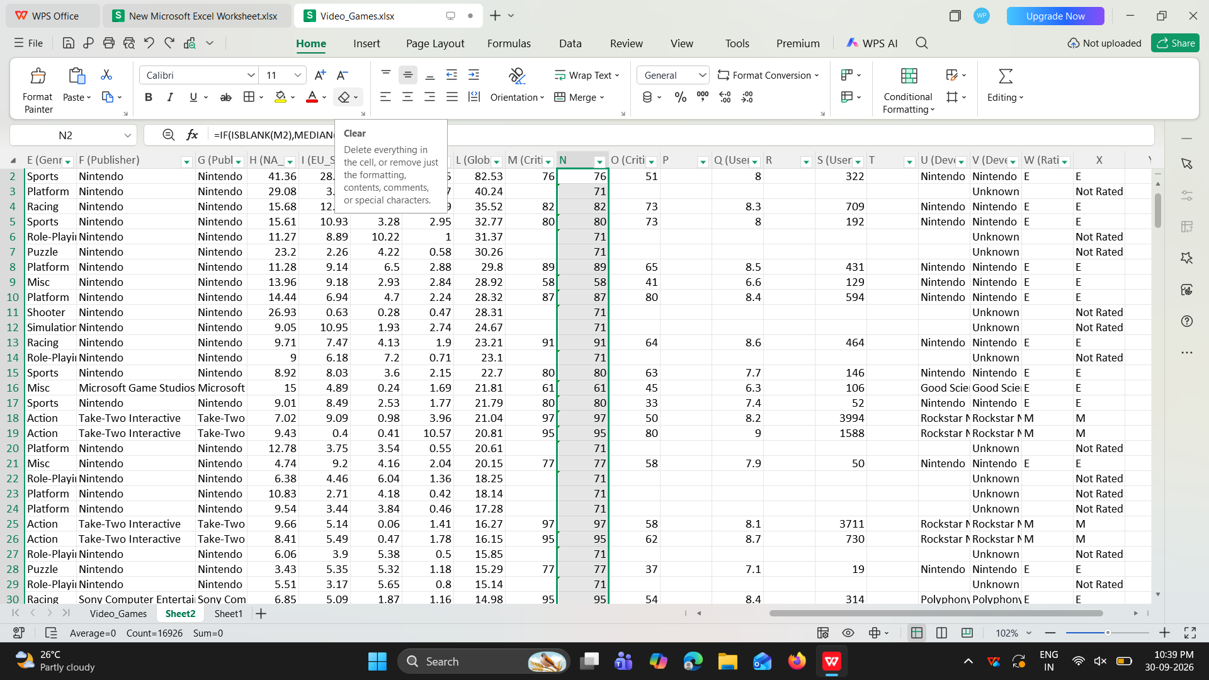

- in user-score coloum there ius tbd text remove using find and replace tool
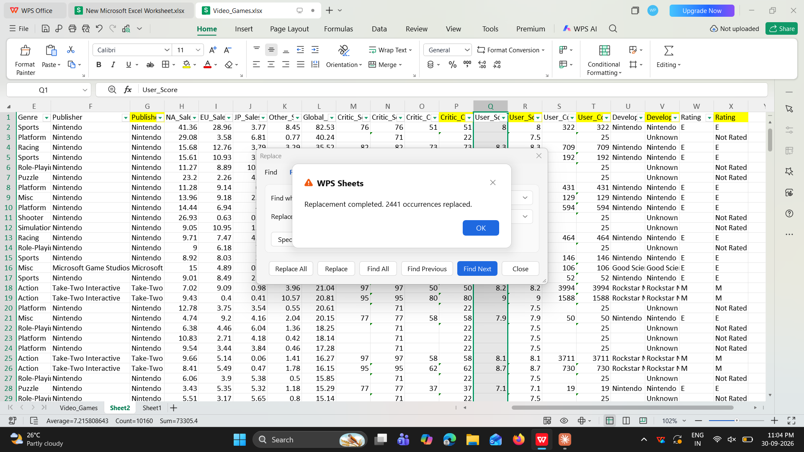

- Sorting
Year of relese and name coloum sorted by smmallest to largest
Select the coloum data tab-sort

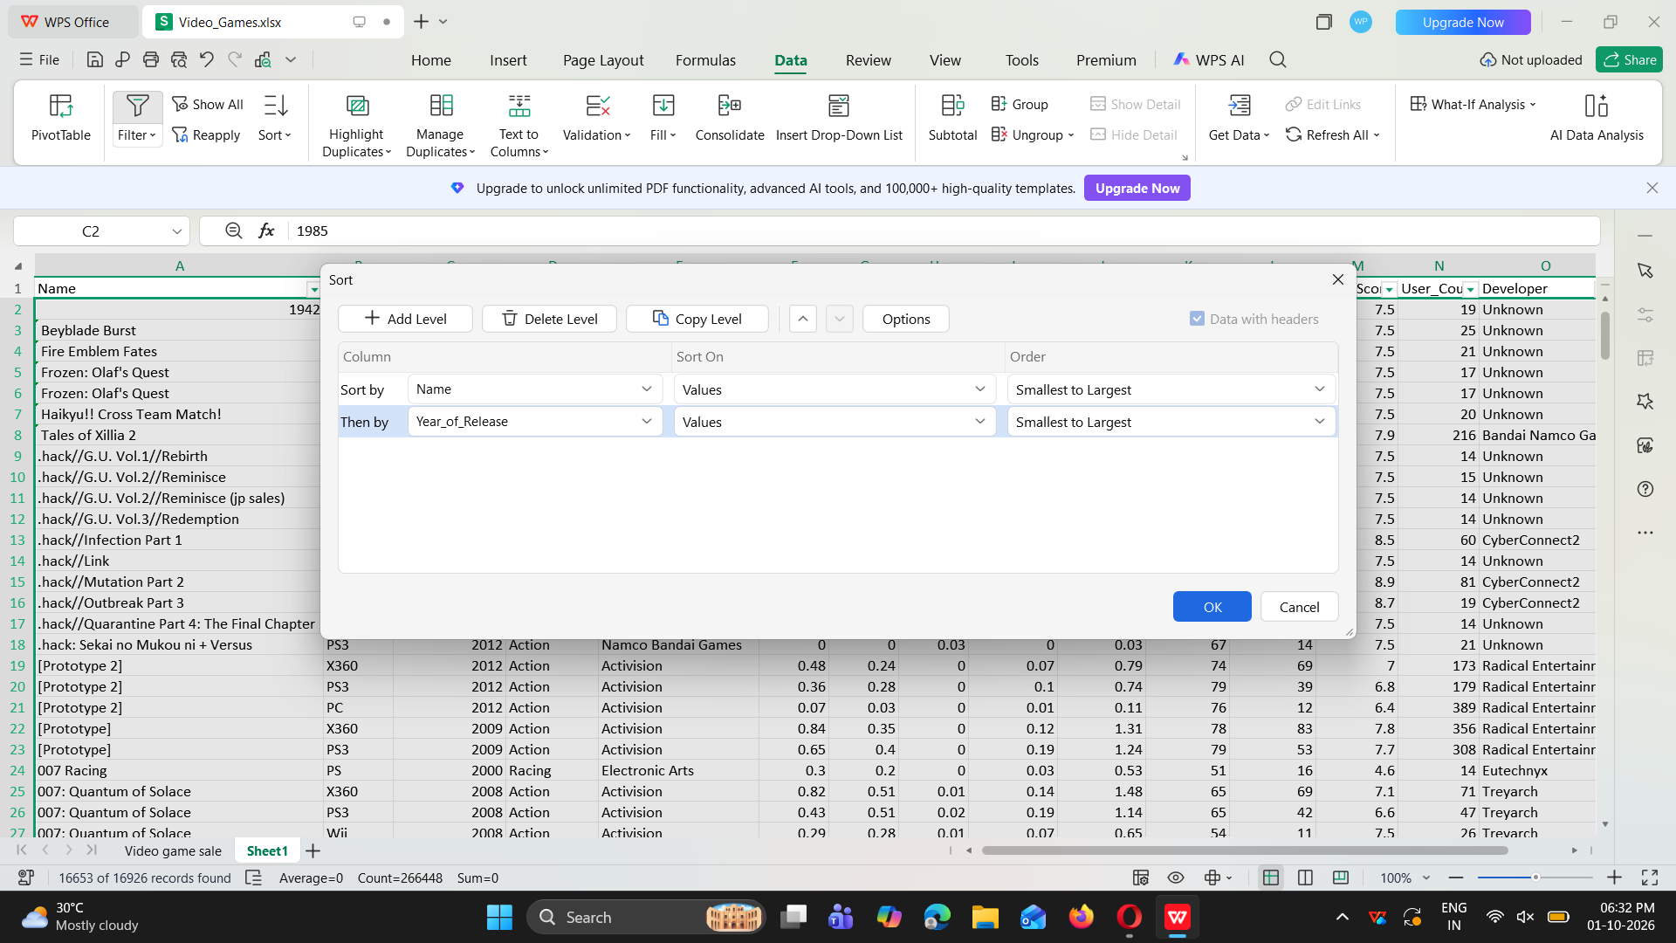
Filtering
To see 2007 sale
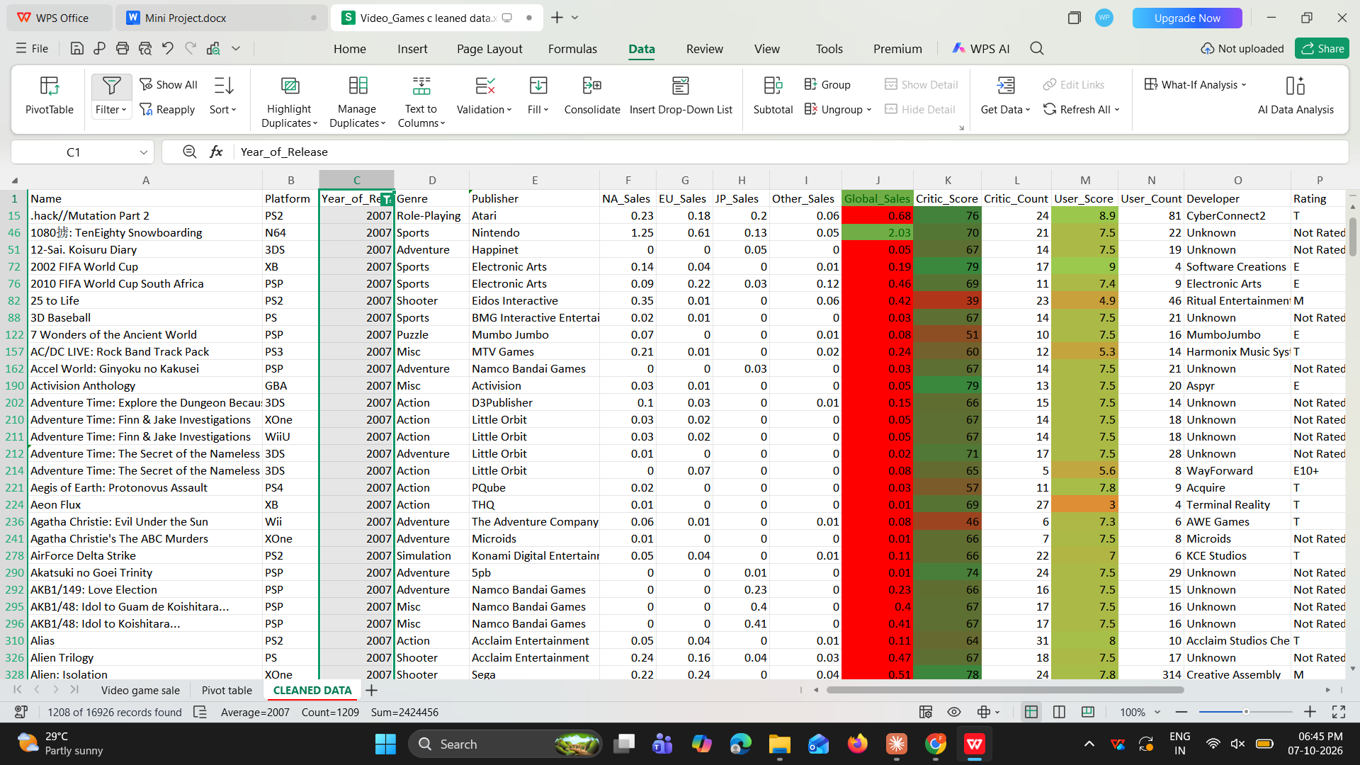
5)calculation
Total Regional Sales=jpsale+na sale+eusale+other sale
=SUM(F2,G2,H2,I2)
Two see the diffrence between region na sale and eu sale
=F2-G2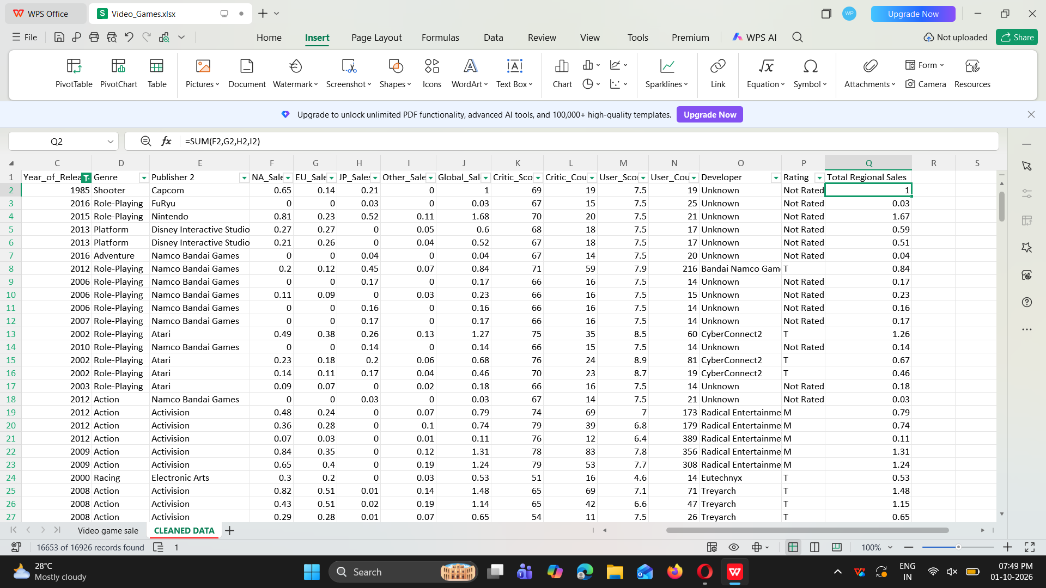

- Conditional formating
Highlite the global sale by great than 1 is green and less than 1 is red
Critic score and user score used colour scale

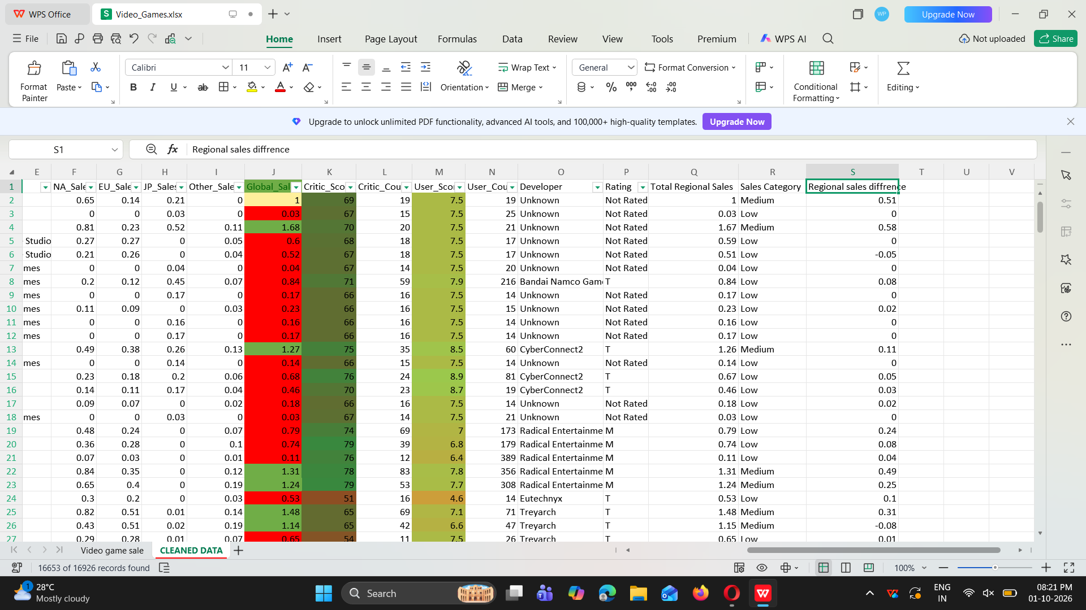

- comparison usinf if function
Global sale compare using if function and made sales category to know its low and high
=IF(J3<1,"Very Low",IF(J3>1,"Low",IF(J3<5,"Medium",IF(J3<10,"High","Very High"))))
Also critic score coloum
=IF(K2<=50,"Low",IF(K2<=70,"Average",IF(K2<=85,"Good","Excellent")))

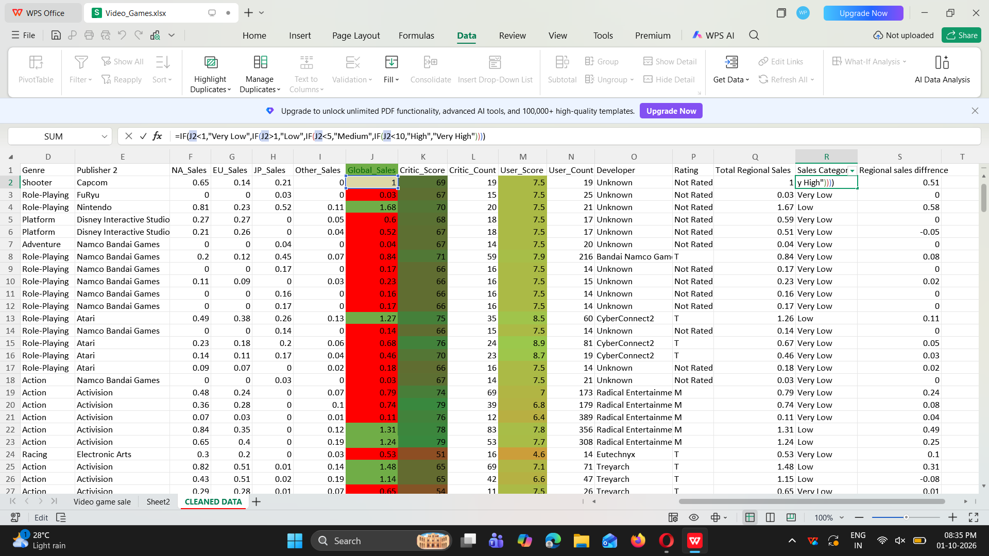

- pivot table for summeraization
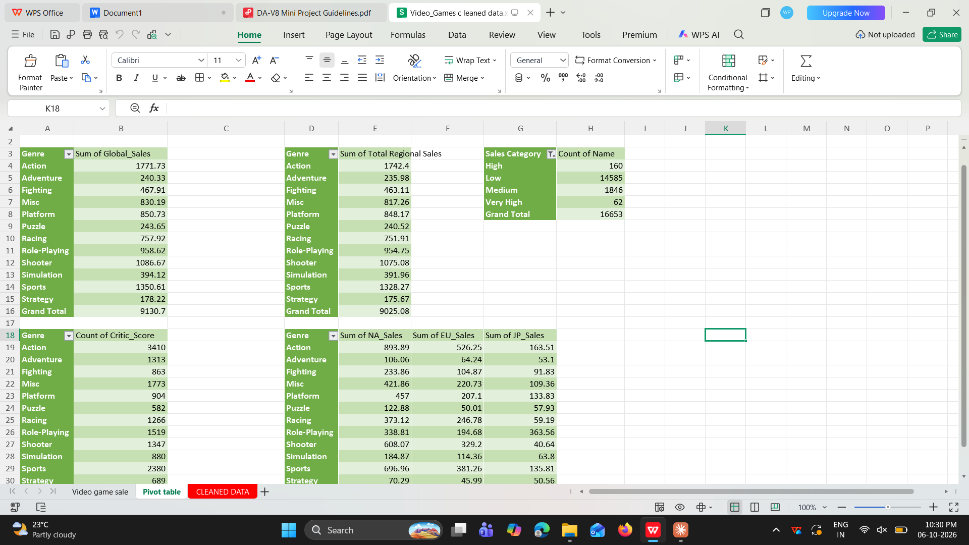

DASHBOARD CREATION USING POWER BI

CHARTS

1)Line chart
X axis =Year_of_Release, Platform,
Yaxis= Sum of Global_Sales
Shows how global sales changed over the years and each platform. It helps you spot peak years and which platforms rose or declined.
Drill down option used
- Pie chart
Legend =Genre → Publisher (drill-down),
Value=Sum of Global_SalesShows each genre's share of total sales. Drilling down shows which publishers dominate a genre
- Clustered column chart
Xaxis=Platform
Yaxis=sum of NA_Sales, EU_Sales, JP_Sales, Other_Sales
Compares regional sales on each platform. It shows which markets (North America, Europe, Japan, other) each platform depends on.
- Scatter chart
Legend =Genre ,
Xaxis =Average Critic_Score
Yaxis = sum Global_Sales
Tests whether higher critic scores lead to higher sales, and which genres stand out.
- Gauge
Count of Rating
Shows how many games carry an age rating
- Clustered bar chart
Y axis =Publisher
X axis = Sum of Global_Sales
Ranks publishers by global sales, which works as a Top N view of the biggest publishers

buttons for rating

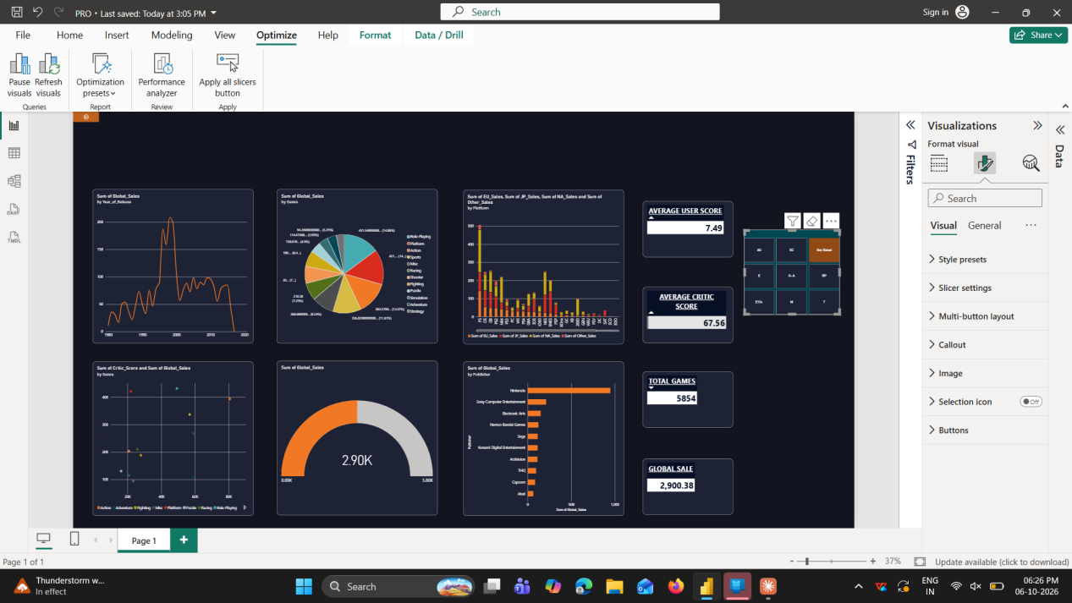

slicer for relesed year 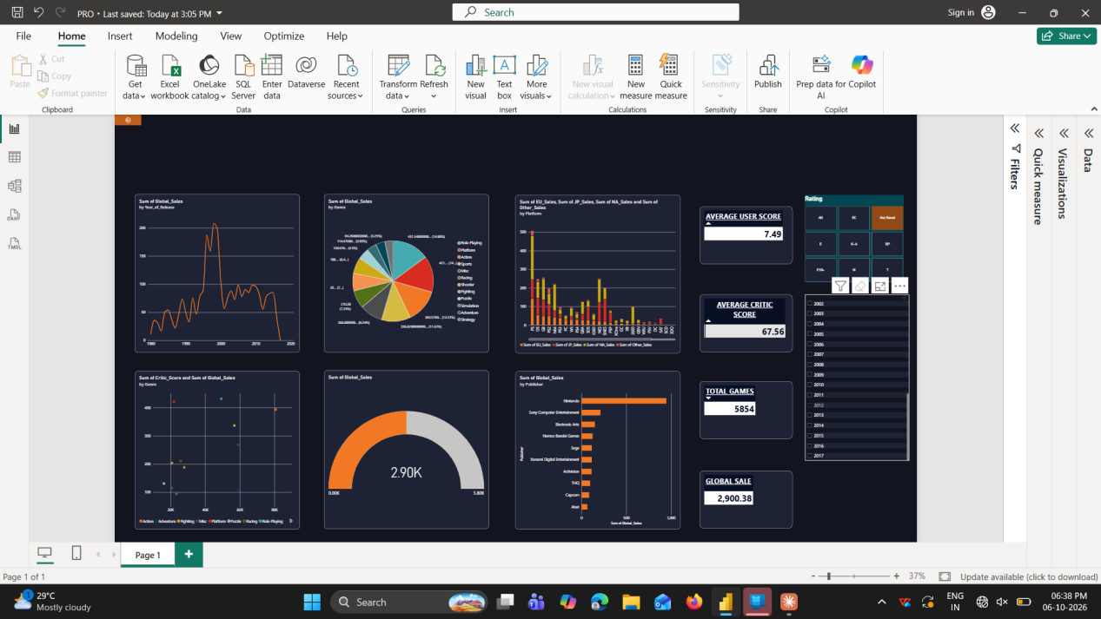
Top 10 filter for clustard bar chart
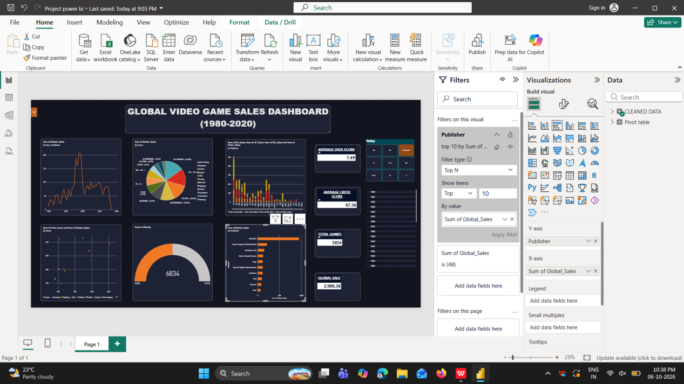

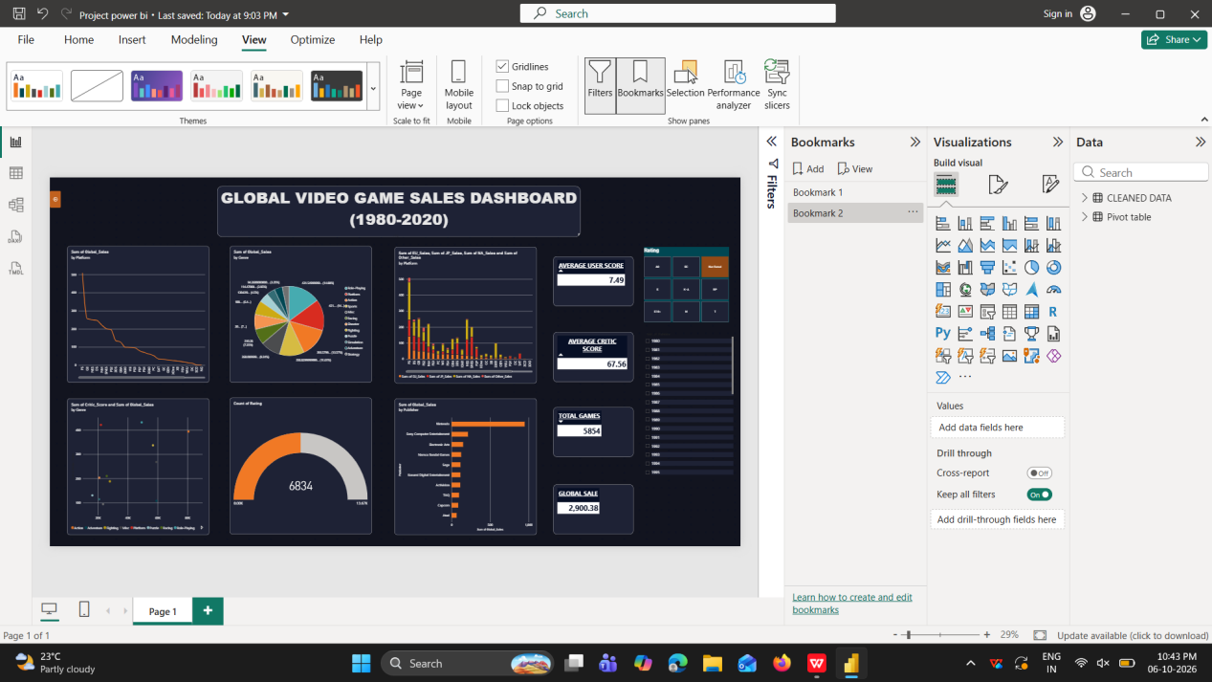

Dashboard
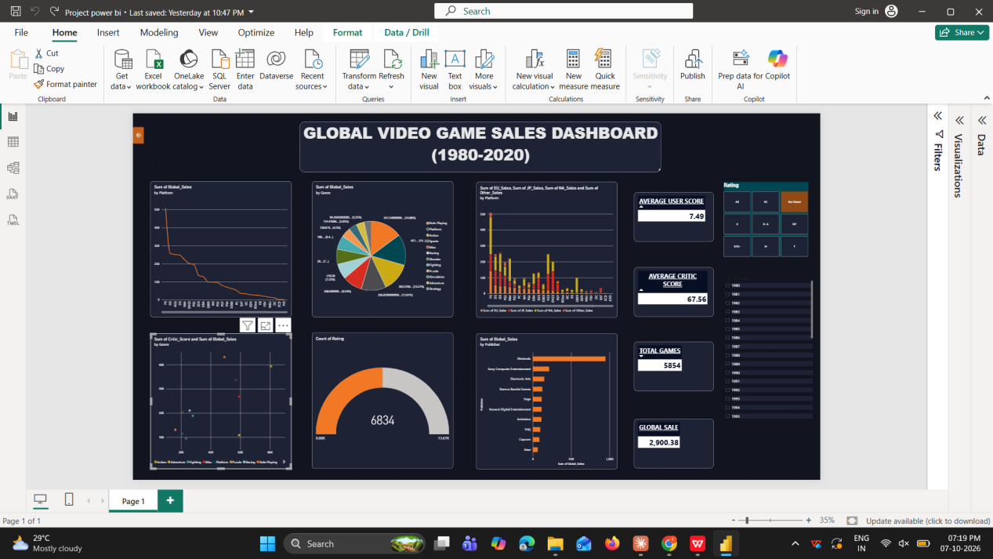

CONCLUSION

The Power BI dashboard analysed global video game sales by year, platform, genre, region and publisher. Sales grew rapidly from the mid-1990s and peaked in 2008 at about 690 million units, then declined, with the very low recent figures likely caused by incomplete data. PS2 was the top-selling platform, and North America was the largest market on almost every platform. Action was the leading genre with about 1.77 billion units (19.4%), and Nintendo was the top publisher with about 1.83 billion units. Average critic scores were similar across genres, yet sales differed widely, so critic scores do not clearly drive sales. A publisher should therefore focus on Action, Sports and Shooter games on leading platforms, tailor releases to each region, and invest in game quality.

